**Iteration 1 Progress Monitoring:**

|  | Iteration 1 | Iteration 2 |
| --- | --- | --- |
| Story points at start of iteration | 343 | 286 |
| Completed during iteration | 29 | - |
| Changed estimates | -28 | - |
| Story points from new stories | 0 | - |
| **Story points at the end of iteration** | 286 | - |

Table 7: Iteration Progress Monitoring

**Iteration 1 Discussion:**

**Story points at the start of the iteration:**  
 In Iteration 1, the team planned and estimated to work on a total of 343 story point worth of tasks

**Completed during iteration:** In iteration 1, the team managed to complete 29 story points worth of work

**Changed estimates:** During iteration 1, the team reduced the estimated amount of story points for the iteration, during the iteration, some tasks were not completed and pushed forward to iteration 2, and minor additions to disaggregated tasks. Resulting in a total reduction of 28 story points.

**Story points at the end of iteration 1:**

Upon completion of iteration 1, the team had a remaining 286 story points which will be passed on to iteration 2

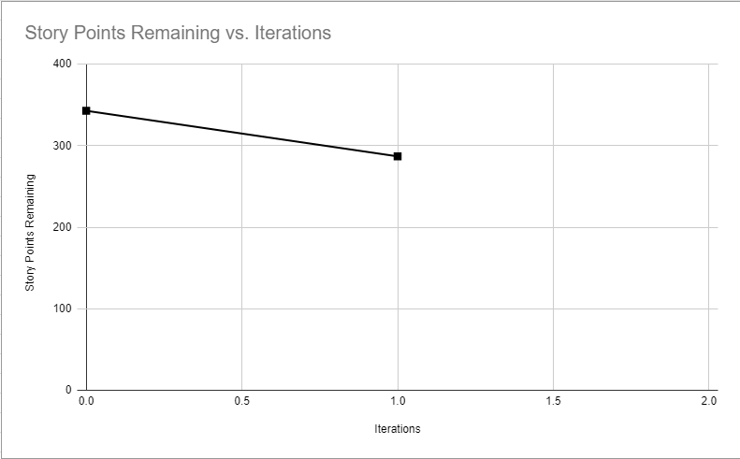

Figure 7: Iteration Burndown Chart

### **2.4.5 Additional Documentation**

For this section, include 1 of 4 videos from your Iteration Planning meetings (recall that you have a total of 4 Iteration Planning meetings)[1]:

1. Showing how your team disaggregated stories into their constituent tasks.
2. How developers on your team volunteer and take responsibilities for tasks.

Provide the file name and URL to the video(s) in your shared folder or YouTube channel.

**Iteration 1 Planning Meeting:** <https://youtu.be/xKzijE52ghQ>

### 

1. Indicate which iteration the video corresponds to. If you decide to submit a video in Release 1.0, then you do not need to include an *Additional Documentation* section for Release 2.0.